- The door should be lifted off the hinges so that the above operations can be carried out on a workbench or similar level surface.

- This should be done when the appliance is cold and unlit.
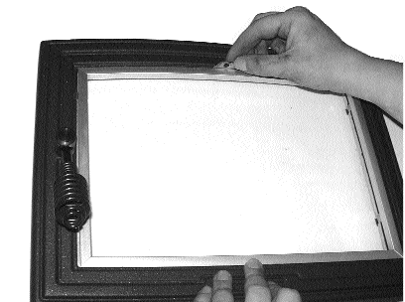

Fig. 1. Removing trim

- Remove the brushed steel finish trim by pressing on the curved edge at the top until the trim can be disengaged from the lugs. (Fig. 1)

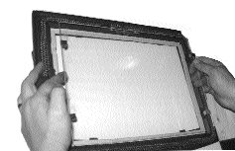
Fig. 2. Removing glass
- Slide the two glass retainer clips on one side only, inwards, towards the centre of the door as far as they will go.

- Pull this side of the glass away from the door casting, easing the tags on the glass retaining clips past the edge of the aperture in the door casting. (Fig. 2)

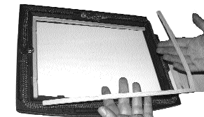

Fig. 3. Removing gasket

- Step 4 Remove the glass completely. Store glass retaining clips and white gasket (if sound) safely for re-use. (Fig. 3)

- Step 5 Follow this procedure in reverse to fit replacement door glass or gasket.

- Step 6 Once the above operations is complete the door glass is ready for use as the picture below shows. (Fig. 4)

Fig. 4. Final door assembly

