Procedure for Retro-Fitting New Fan Flue Motor (L00590AXX)

The new fan motor comes with the following parts (see figure below):
- Fan Flue Motor
- Mounting Bracket
- Pressure Hose
- Pressure Hose Adaptor
- 4 off No.6 x 6mm Self Tapping Screws

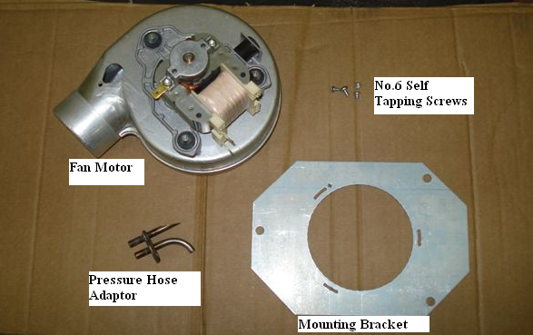

The following is a procedure for fitting the new fan motor assembly (BOM Code: L00590AXX):
- Assembly the new fan motor by fitting it to the mounting bracket supplied using three of the No.6 self tapping screws (ensuring that the bracket is orientated as shown in Figure 1), and fit the pressure hose adaptor using the remaining self tapping screw (see Figure 2).

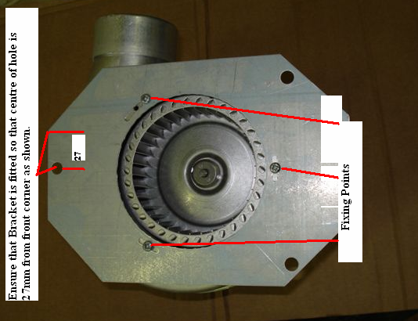

Figure 1

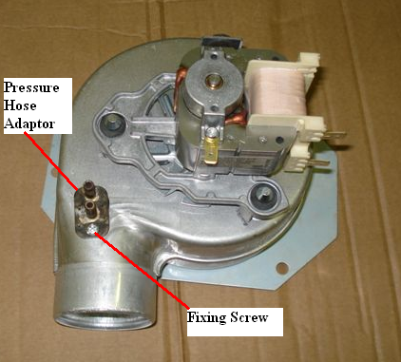

Figure 2

- Disconnect the wiring from the fan motor & remove the old fan flue motor by removing the three M5 fixing screws. Insert the new motor assembly by fixing it in position using the three M5 screws (see Figure 3).

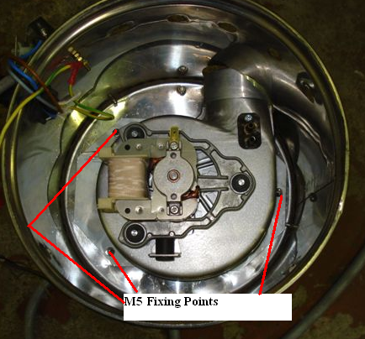

Figure 3

- Fit the pressure hose supplied with the kit to the rear connection of the pressure hose adaptor and the + connection on the pressure switch (see Figure 4). Connect the existing hose, which is connected to – connection on the pressure switch to the front connection of the pressure hose adaptor.

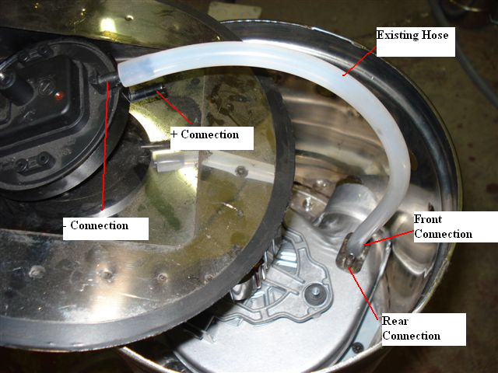

Figure 4

- Reconnect the fan motor wires as follows:
- Green or Brown – Live to Fan Motor
- Blue – Neutral to Fan Motor
- Green/Yellow – Earth to Fan Motor

