BRANSDALE MULTI-FUEL STOVE
INSTALLATION AND USER INSTRUCTIONS

The Bransdale stove has a nominal heat output of 8kW., and a weight of 100 kg. The flue gas mass flow is 4.8g/s for mineral fuel and 6.1g/s for wood logs. The mean flue gas temperature directly downstream of the flue spigot at nominal heat output is 360 degrees C. The stove is designed as a closed appliance and is capable of intermittent operation.

The stove must be installed to comply with Health and Safety at Work Act 1974, and to all local Building Regulations, including those referring to National and European standards. These need to be complied with when installing the appliance.

UNPACK THE STOVE

Carefully cut the straps and lift the box up over the top of the stove. Remove the packing from round the outside of the stove, leaving the plastic cover on if building work is still in progress, it is important to protect the black finish from any damage, water, dust or fire cement. Using a 17mm spanner, remove the two bolts attaching the stove to the pallet, and then replace the bolts into the stove legs, these are used as levelling bolts if required. Open the stove door and remove the packaging from inside the stove, there is some behind the baffle, and the heavy one inside the stove contains the spigot and blank for the flue outlets. Remove the bag inside the ashpan, this contains the operating tool, instructions, stove handle cover and a pair of stove gloves.

CLEARANCES

The Bransdale is to be sited next to and on a non-combustible surface. A minimum clearance of 150mm at the sides, 300mm above and 50mm from the back of the stove body will allow air circulation and not impede the performance of the stove. If it is necessary to site the stove near a combustible surface a minimum of 350mm at the back, and 650mm at the sides must be maintained. This appliance is to be installed on a solid, level, non-combustible hearth extending 300mm in front of the stove and conforming to current Building Regulations.

INSTALLATION

A minimum flue draught of 20 Pa is required for nominal heat output. The Appliance must be installed on a floor with an adequate load-bearing capacity. If an existing construction doesn’t meet the prerequisite, suitable measures (e.g. load distributing plate) shall be taken to achieve it. As referred to in document J in the Building Regulations, The Bransdale requires 1650 sq mm of fixed ventilation. It is important that any inlet grilles are so positioned that they are not liable to blockage.
If the stove is to be fitted with a top flue, fit the collar on the top of the stove and the blanking plate on the rear. Or the other way round if the flue is to be fitted from the rear of the stove (see figure 1). A flat-bladed screw driver and 8mm spanner will be required.
The Bransdale requires a Class 1 chimney of it’s own, a shared chimney will not be suitable. The chimney must be sound, free from leaks and swept before installation. If the chimney requires lining, a lining must be used which is suitable for wood and solid fuel, with a minimum of 150mm internal diameter. A metre of flue pipe should be used from the stove before the chimney lining, and the lining must be installed to manufacturers instructions. Alternatively, if there is no chimney, then an insulated stainless steel flue may be used, to B.S. 4543, with a minimum of 150mm internal diameter, and must be installed to manufacturers instructions and to relevant Building Regulations. The length of the chimney or flue must be at least 4 metres from the top of the stove, and must finish in a down draught free area. A stove must not be installed into a room where there is an extractor fan, or fumes could be pulled down the chimney.

It is essential to provide a facility for sweeping the chimney, and this may be done by installing a soot door in the brickwork, or providing an access plate in the register plate or flue pipe. When the flue is fitted from the top of the stove, the baffle can be removed to sweep up through the stove.

Connect the stove to the chimney using vitreous enamelled flue pipe, either from the top of the stove, or from the rear. Horizontal flue must be kept to a minimum, no more that 150mm is allowed. Make sure that all joints and connections are well sealed.

When installation is complete, allow a suitable time for fire cement and mortar to dry, light a fire and make sure all joints are sealed. The stove is painted with a high temperature paint finish. The paint will be cured when most surfaces have reached about 246 degrees C. During this burn off period you will notice an unpleasant smell; you should not touch or wipe the paint during this period as it will be soft and may mark. The room should be well ventilated , children and pets should be kept away. Do not use water to clean the stove, either before or after it is cured.

LIGHTING THE STOVE

When ready to light the stove for the first time, make sure that everything is removed from the ashpan , and open the spin wheels at the bottom and top of the stove to let air in under the grate. First burn some newspaper in the stove, with the door closed, to warm the flue, as there may be down draught initially. The temperature in the flue has to be increased to change the down draught to up draught. If down draught persists, try burning a blow torch in the stove, facing the flue for a minute or two. If there is a soot door fitted, try warming the flue through the soot door. If this does not work, call in your installer. If the stove has not been lit for a while, the chimney should be checked for blockages before lighting.
When ready to light the stove, put a small piece of fire lighter, about 25mm square is big enough, and then add small sticks, taking care not to smother the flames. When the sticks are well alight add small logs, gradually increasing the size. Once the fire is well
Established and hot the bottom spin wheels can be closed, and the fire can be controlled from the top air controls, without having to bend down. The spin wheels do become hot, so use a glove or the tool provided to open or close the air vents, they only need moving slightly to open or close the air gap. When burning solid fuel, it may be necessary to leave the bottom air vents slightly open. A stove handle cover is included with the stove – place the black cover over the handle when opening and closing the door, then remove and leave near the stove.

The appliance will give more heat output with increased air supply, so the controls can be adjusted to increase or decrease the burning rate of the fuel, as desired.
This appliance is hot whilst in operation. Keep children and furniture a safe distance away.

To close the stove down, close the bottom spin wheels and the top spin wheels. Depending on the fuel and the amount of draught in the chimney, it may be necessary to leave the top vents open slightly to allow the glass to burn clean, and it may be necessary to leave a small amount of air through the bottom air vents when burning certain solid fuels. DO NOT OPEN THE BOTTOM SPIN WHEELS WITH THE TOP ONES CLOSED, THIS WILL DAMAGE THE GLASS. When all the spin wheels are closed, the glass may become black because the clean burn will be shut off. To burn the glass clean, make a good fire to get the stove hot, close the bottom vents and leave the top spin wheels open.

The appliance is designed to operate efficiently with the fire door closed. The door should be kept closed at all times, except when refuelling or removing ashes.

TO RE-FUEL THE STOVE

Open all air vents and then open the stove door gently, using the stove gloves. Put more logs or solid fuel on the stove and close the door. Do not over fill the firebox, maximum
filling height 100mm. Allow the fire to burn through before closing the bottom spin wheels and then close the top spin wheels as much as required.

FUELS

This appliance has been tested using seasoned wood logs and manufactured briquetted smokeless fuel (Ancit) for closed appliances, sized between 20g and 140g. Other fuels are commercially available and may give similar results. Do not use household coal. It is a good idea to try small quantities of different fuels until you find one that suits your chimney. Petrocoke or any petroleum based fuel must NOT be used, they burn excessively hot and will destroy parts of the stove in a very short time. If using logs , the logs need to be dry, seasoned logs, ie. no more than 20% moisture content, maximum log length up to 440mm. Small pieces of kiln dried timber can burn very hot, take care that the fire does not get out of control. The stove is designed to burn wood or solid fuel, DO NOT BURN ANY LIQUID FUEL. DO NOT BURN WOOD PELLETS. DO NOT BURN WOOD CHIPS. DO NOT BURN ANY RUBBISH ON THE STOVE.

WARNING – USING A NON APPROVED FUEL MAY CAUSE DAMAGE TO THE STOVE AND WILL NOT BE COVERED BY OUR GUARANTEE. WOOD NEEDS TO BE DRY AND SEASONED ( MAXIMUM 20% MOISTURE CONTENT)
DO NOT BURN ANY LIQUID FUEL. DO NOT BURN WOOD PELLETS.DO NOT BURN WOOD CHIPS. DO NOT BURN ANY RUBBISH ON THE STOVE. DO NOT USE HOUSEHOLD COAL, HIGH PETROLEUM BASED FUELS, PETROCOKE, BURNWELL OR ANTHRACITE. ( A COMPREHENSIVE LIST OF APPROVED FUELS FOR CLOSED APPLIANCES IS AVAILABLE ON THE HETAS WEBSITE)

CLEANING THE STOVE AND FLUE

The grate is a fixed grate, so use a poker to move ash into the ashpan . It is important to remove the ashes regularly, if the ash builds up through the grate, the grate could overheat and distort.
Open the fire door with the stove glove provided, and, using the tool, gently pull out the ashpan a little way. Then remove the tool and slot it in from the top of the slot in the middle of the ashpan. The tool will then have a firm grip on the ashpan . Carefully carry the ashes out to dispose of them, or use a ‘Tippy’ or similar ash carrier.
When the stove is being used regularly, it will be necessary to remove the baffle once a year to clean any debris that may have collected there. The chimney/flue should be swept and checked every year. The glass on the stove door can be cleaned (when the glass is cool), using a damp cloth, or sponge pan scrubber for any stubborn marks. Stove glass cleaner may be used if required.

The body of the stove can be brushed with a soft brush , do not use water on the paint work. If, in time, the body of the stove needs touching up, a touch-up aerosol of paint, the same as originally used in the factory, can be obtained from you supplier.

This appliance should be regularly maintained by a competent service engineer.

There must be no unauthorised modification of the appliance. Any replacement parts must be recommended by the Manufacturer.

TROUBLE SHOOTING

1. The stove is not burning well.

The stove may need more fuel loading - load more fuel, see ‘lighting the stove’
The wood may be un-seasoned or damp - avoid using unsuitable wood, burn smokeless fuel until the wood is dry and seasoned.
The chimney may need sweeping, or there may be a build up of debris above the baffle - see ‘Cleaning the Stove and Flue’
The fuel may be too hard, e.g. some anthracites and cokes require a lot of draught to maintain a high burning temperature, so try a solid fuel that burns at a lower temperature. There may not be the required flue draught in the chimney/flue. In this case a longer chimney pot may help, or there may be a blockage in the flue.

2. Smoke is coming into the room.

There may be down draught conditions, see paragraph 1 of ‘Lighting the Stove’. If it is not possible to stop the down draught by warming the flue as described, it is advisable to leave the stove unlit and test conditions later.

3. The stove is burning too hot.

Make sure the stove door is closed properly, and check that all spin wheels are closed.
Check the rope seal on the door. If this needs replacing, ceramic rope and heatproof adhesive can be obtained from your supplier.

IN CASE OF A CHIMNEY FIRE - CLOSE ALL AIR VENTS IF POSSIBLE. MAKE SURE THERE IS NOTHING COMBUSTIBLE NEAR THE STOVE. MOVE PEOPLE AWAY FROM THE ROOM.
CLOSE THE ROOM DOOR
PHONE THE FIRE BRIGADE.

ISSUE No. 2 01/04/2013
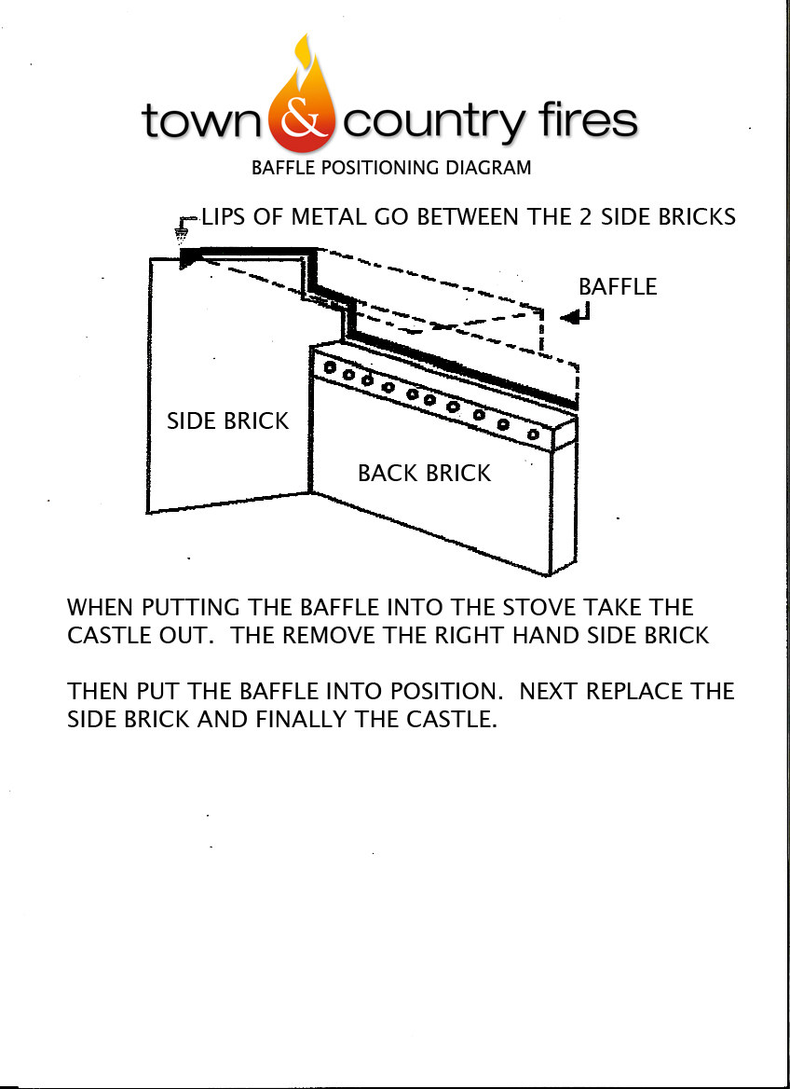

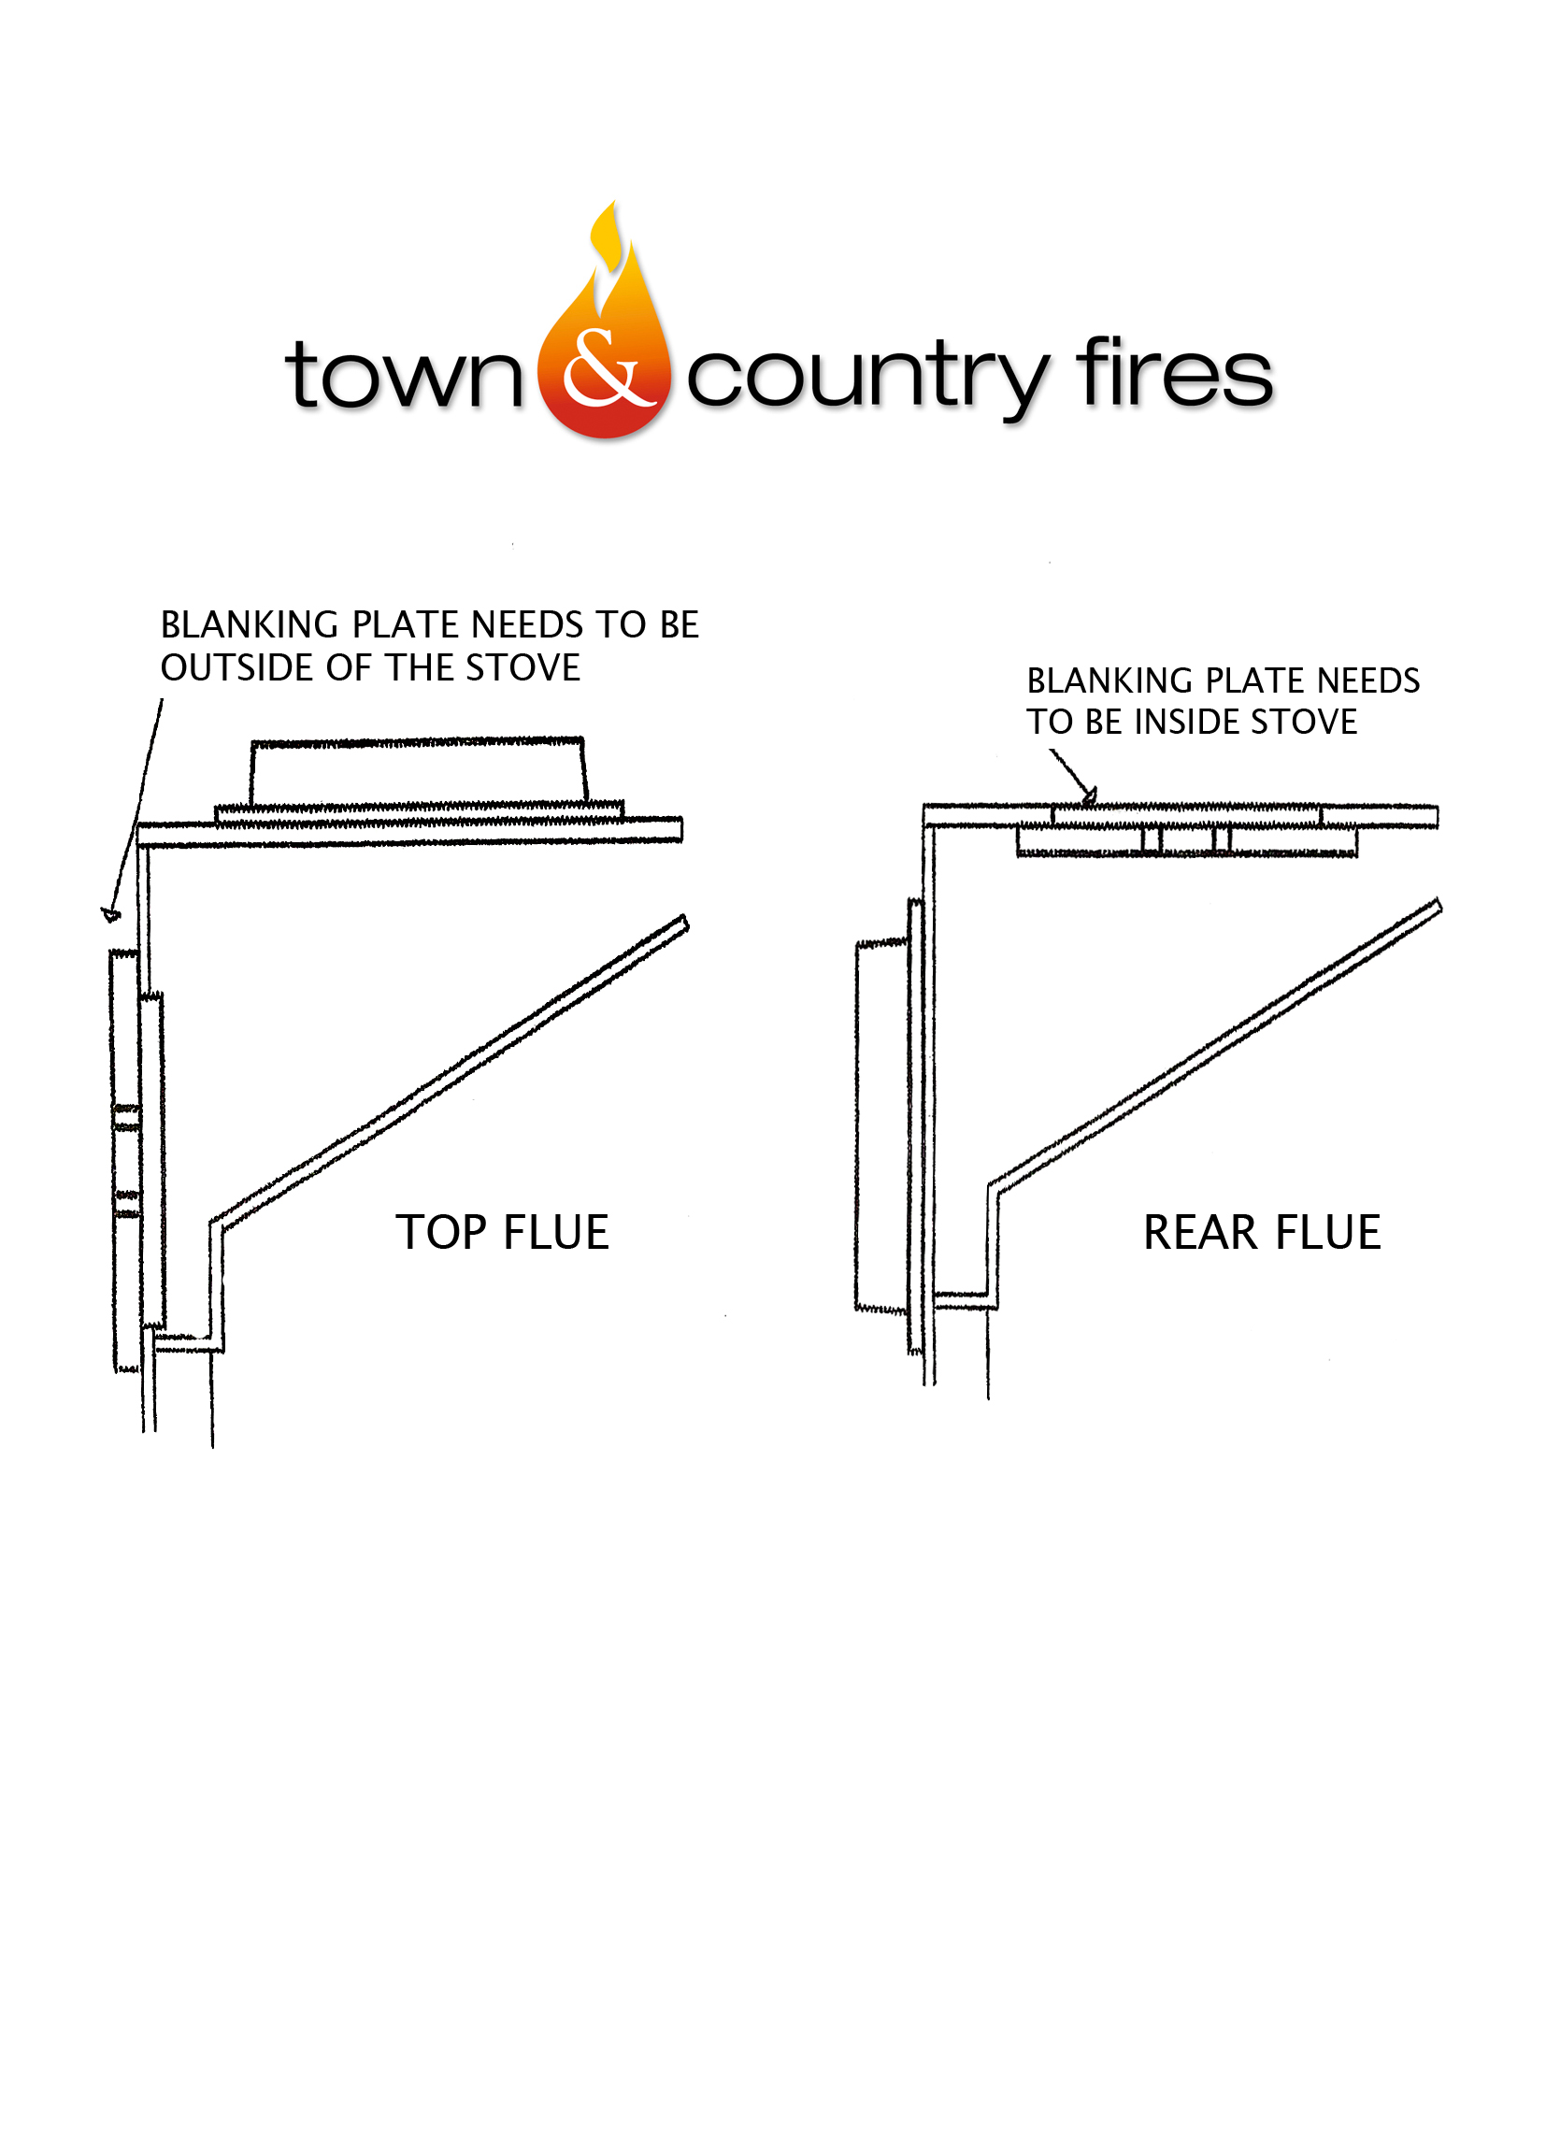

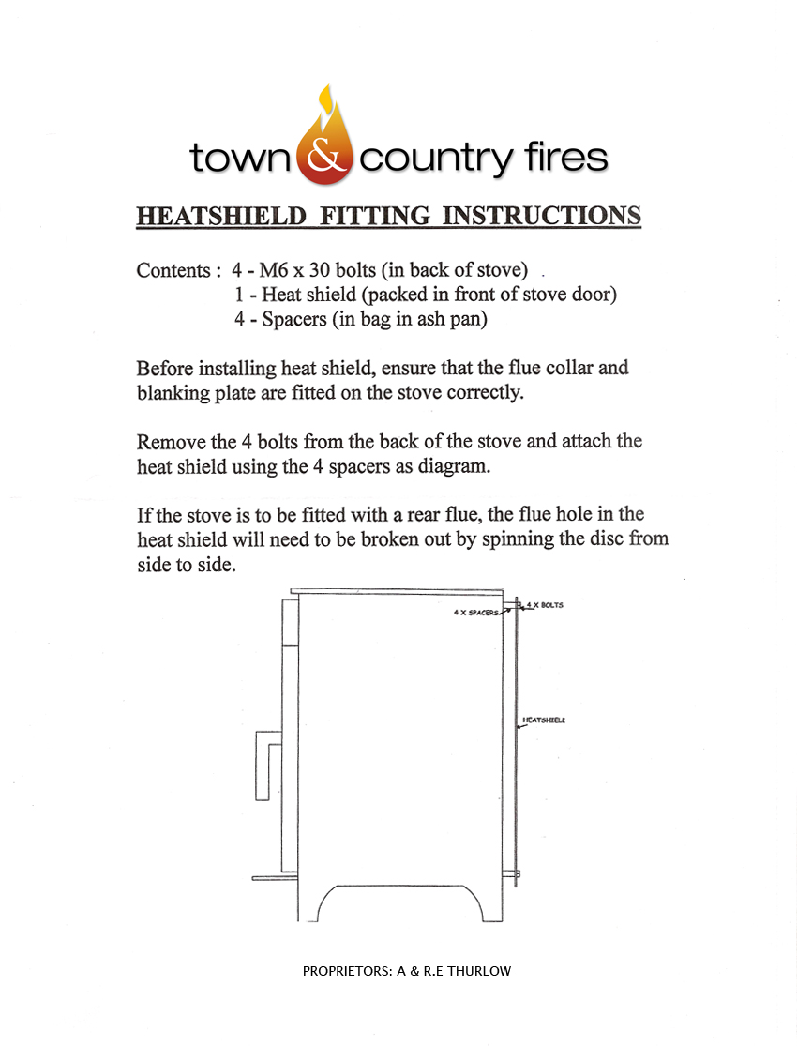

The Town and Country Fires Guarantee

Town and Country Fires Ltd guarantee the quality of workmanship of their multi fuel stoves for twelve months from the date of purchase.

Stoves must be installed to current Building Regulations , National and European Standards and per our Installation / User instructions supplied with the stove. Installation must be carried out by a competent installer.

Using a non approved fuel may cause damage to the stove and will not be covered by our guarantee,.
Wood needs to be dry and seasoned ( maximum 20% moisture content) . Do not use household coal, petroleum based fuels, Petrocoke, Burnwell and Anthracite. ( A comprehensive list of approved fuels for closed appliances is available on the HETAS website )

Usage of our multi fuel stoves should be as per our Installation / User Instructions provided with the stove.

Any warranty claim requires Proof of defective workmanship and delivery of the defective product to our factory within twelve months of the date of purchase.

Parts which are classed as consumables and are excluded from our Guarantee include;

Grates, Fire Bricks, Baffles, Fuel Guards, Ash Pan, Glass , Door / Glass Seals and Paint.

Claims under this guarantee should be made through the Approved Town and Country Dealer the appliance was originally purchased from.

Please complete the enclosed form in full to validate your guarantee, and extend the guarantee from one year to ten years. Please note the extended guarantee is only valid when your stove was purchased from a Local Approved Town and Country Dealer and not a third party reseller.

Town and Country Fires are not liable for any incidental loss, damage or injury, however caused.

This Guarantee is only applicable in the UK .

This Guarantee does not effect your statutory rights.

Please keep this page for your future reference.

Issue No. 01 01/03/2010

Congratulations on your purchase of a Town and Country Fires Multi Fuel Stove.

Please complete the following to validate your guarantee from one to ten years and return in the pre paid envelope to;
Town and Country Fires Ltd, Unit 1 Enterprise Way, Thornton Road Ind Estate,
PICKERING , North Yorkshire YO18 7NA

Model :…………………………….................................................Serial No.BRA:…………………*

Date of Purchase:……………………………...............………...............................................................

Title:……………….. Surname:……………………………...………………........................................

Address:…………………………….........................................................................................................

………………………………...................................................................................................................

Date of Installation:…………………………….......................................................................................

Installers Name:…….................................................................................................................................

Address:…………………………….........................................................................................................

………………………………...................................................................................................................

Tel. No……………………………..………….........................................................................................

Supplier Details;

Name:……………………………............................................................................................................

Address:……………………………........................................................................................................

………………………………..................................................................................................................

Tel. No………………………………......................................................................................................

Thank you for your co-operation, if you do not wish to be contacted by Town and Country Fires in the future please tick this box

* Serial number is located on the metal data plate on inside of fire door.

